Unit Conversion App: Development Process

Mark Hahn

Colorado State University Global Campus

CSC475

Professor Thakkar

8/27/24

# Unit Conversion App: Development Process

The primary objective of the Unit Conversion App is to provide users with an intuitive and efficient tool for converting various units of measurement, including temperature, length, and weight. The app facilitates conversions between Celsius and Fahrenheit, meters and feet, and kilograms and pounds, ensuring that users can quickly obtain accurate results without requiring manual calculations. By implementing this app, the goal was to create a simple yet powerful utility that could be used in educational, professional, and personal settings.

## Obstacles Faced During Development

Several challenges were encountered throughout the development process. The first major hurdle was ensuring the accuracy of the conversion formulas. Each conversion required precise mathematical calculations, and even slight inaccuracies could lead to significant errors, particularly in scientific or professional contexts. Debugging and testing these calculations were critical to overcoming this obstacle.

Another challenge involved designing a user-friendly interface that catered to the majority of users. Ensuring that the UI was intuitive and straightforward, while avoiding a bloated/overdone application for what it was meant to do. The Android Layout Editor tool was particularly useful in this process, allowing for easy visualization and adjustment of the interface components Android Developers (n.d.). Additionally, integrating the various conversion functionalities into a single cohesive application without cluttering the user experience posed its own set of difficulties.

## Skills Acquired

The development of the Unit Conversion App contributed significantly to the enhancement of several technical and problem-solving skills. First and foremost, I deepened my understanding of the Kotlin programming language and Android development environment. The process of implementing conversion functions and linking them with the UI components honed my skills in Kotlin syntax, function design, and object-oriented programming principles.

Moreover, I gained practical experience in applying the Android Testing Framework to create unit tests that ensure the reliability and accuracy of the app’s conversion logic. Writing and executing these tests not only solidified my knowledge of testing methodologies but also underscored the importance of rigorous testing in software development GeeksforGeeks (2021).

Finally, I developed a stronger grasp of user interface design principles, particularly in the context of mobile applications. Through iterative design and feedback, I learned how to balance aesthetic appeal with functionality, ensuring that the app is both visually pleasing and easy to use.

**Screenshot**

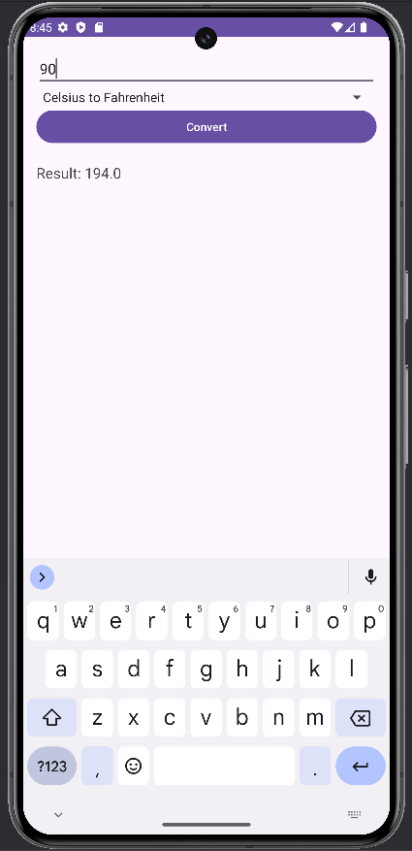

*Image of Conversion App running on a Pixel 8 Emulator*

# Conclusion

The development of the Unit Conversion App provided a valuable learning experience that extended beyond mere coding. By overcoming challenges related to accuracy, UI design, and testing, I was able to produce a functional and reliable application that meets the needs of its users. The skills acquired during this project, including proficiency in Kotlin, Android development, and testing frameworks, will undoubtedly serve as a solid foundation for future software development endeavors.

# References

Android Developers. (n.d.). Develop a UI with Views. *developer.android.com.* Retrieved from <https://developer.android.com/studio/write/layout-editor>

GeeksforGeeks. (2021). Unit Testing in Android using JUnit. *geeksforgeeks.com.* Retrieved from <https://www.geeksforgeeks.org/unit-testing-in-android-using-junit/>